**Oracle WebCenter Sites Training Proposal**

Proposed By:

[Tushar Singhal](https://in.linkedin.com/in/tusharwebcentersitestrainer)

Trainer and solution consultant

**Training Title:**

Oracle WebCenter Sites 11g/12c Training

**Training Purpose:**

During the training, we will be covering a series of practices that will help in understanding the implementation concepts of Oracle Webcenter Sites/Fatwire that include the site creation, users creation, roles and permissions. By the end of the training, trainees will develop new skills to build out asset models, configure the user interface for content contribution and content management and configure various modes of publishing.

we will also be developing a sample site using Oracle WebCenter sites 11g/12c and which that help in understanding the functional and practical aspects of the tool.

**Training Objective:**

* Create and manage a content management site in Oracle WebCenter Sites
* Configure aspects of the user interface based on user roles and permissions
* Develop templates and element code using WebCenter Sites custom JSP tag libraries
* Implement in-context content editing, presentation editing, and content creation
* Produce a fully functional webcenter sites driven website

**Training Audience:**

* Solution Architect
* Application Developer
* Developer
* Implementation Consultant
* J2EE Developer
* Java Developer
* Technical Consultant

**Course Content:**

Oracle WebCenter sites Architecture and Interface

* Basic Architecture of Oracle WebCenter Sites
* About WebCenter Sites Terminology
* The WEM Admin Interface : Administration
* The Admin interface
* The Contributor Interface: Content Creation

Creating and configuring a new CM site

* Discussing User Authentication and Authorization
* About Oracle WebCenter Sites roles,
* Users and ACLs
* Creating a CM site in WebCenter Sites
* Creating users in the WEM Admin interface
* Creating and assigning roles in the WEM Admin interface to a site

Asset Model

* Creation of Basic Assets
* Creation of Flex family Assets
* Database table associated with the Assets
* Page, Template, CSElement, Site Entry and other Default Asset Types
* Creation of Definition, Parent Child Definition
* Designing asset model for the Sample sites
* About Asset Dependencies

WebCenter Sites Developer Tools and Tags

* Overview of Oracle WebCenter Tags
* Sites Explorer
* Template Creation and Integration with Eclipse

Attribute Editors

* Types of Attribute Editor
* Customized Attribute Editor

Start Menu

* Configuration of New Start Menu
* Configuration of Search Start Menu
* Configuration of Insite Start Menu
* Assigning roles and sites to Start Menu

In Context Editing: Web Mode

* Discussing Requirements for In-Context Editing
* Coding for In-Context Content Editing
* Coding for In-Context Presentation Editing

Localization of the Site

* Configuration of Dimension and Dimension Set
* Development of locale based assets

Java Asset API

* Creation of Asset
* Deletion of Asset
* Data Migration
* Searching of Asset

Filters

* Configuration of Filters
* Site build in Filters
* Creation of New Filters

Engage

* User Targeting and Personalization
* Segment
* Recommendation

Revision Tracking

Logging

* Configuration of loggers
* Addition of loggers In site

Publishing

* Publishing Methods
* Explaining Approval Process
* Creating a New Destination for Dynamic Publishing
* Approving and Publishing Content Assets

**Software Required:**

**For 11g**

* Windows 7
* JDK 1.6 or above
* Oracle WebCenter Sites JSK 11.1.1.8 (Apache server) patch 17157514/ Oracle WebCenter sites 11gR1 (11.1.1.8.0)
* Oracle 10g database
* Firefox browser
* Notepad ++

**For 12c**

* Windows 7
* JDK 1.8
* Oracle Database 12c
* Oracle Weblogic 12c
* Oracle JSK 12C / Oracle WebCenter Sires 12c (12.1.1.0)
* Chrome/Firefox browser
* Notepad++

**Hardware Required:**

* Intel i3/i5 processor
* Min. 8 GB RAM

**Training Material:**

* Detail Project on Oracle WebCenter Sites covering all the concepts of WebCenter Sites.
* Code of the Detail Project.
* Hands on instructions document.
* Sample site as an Assignment.
* Recorded Videos of the live sessions.

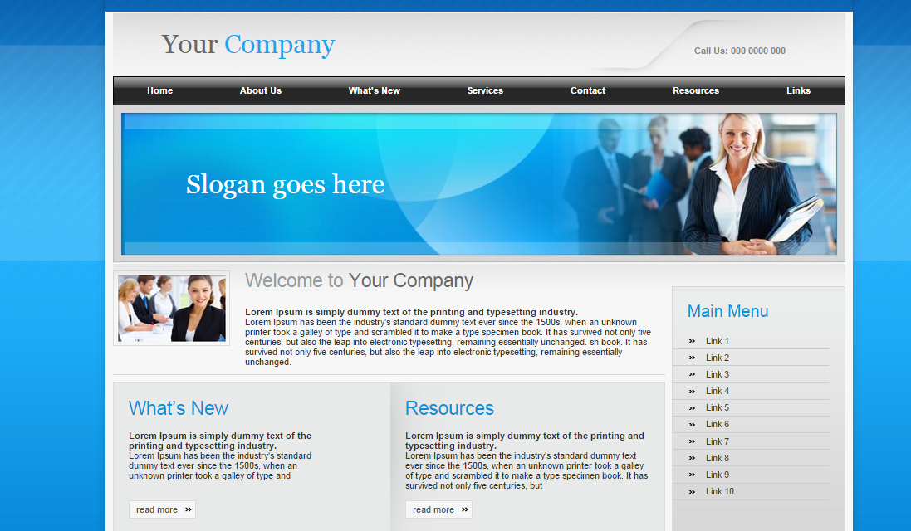

Fig: Sample Site